Project plan

# Main Objectives/Outcomes

* Set up and solve a model describing the dynamic behaviour of a flat plate solar collector
* Design and set up an experiment to test the model for its validity
* Comment on the validity of the model
* Optimize the variable inputs (or design parameters of the collector) for a region of which the meteorological data is known.
* (Optional) Play around with the air composition inside the collector, to determine the effects of pulling a vacuum inside the collector.

# Experimental

* The solar collector is the most important hardware I will need. Other needs involve piping, a storage tank, a pump, at least 2 thermocouples, and a flowmeter. I will also need a way to log the data.
* Experimental setup:

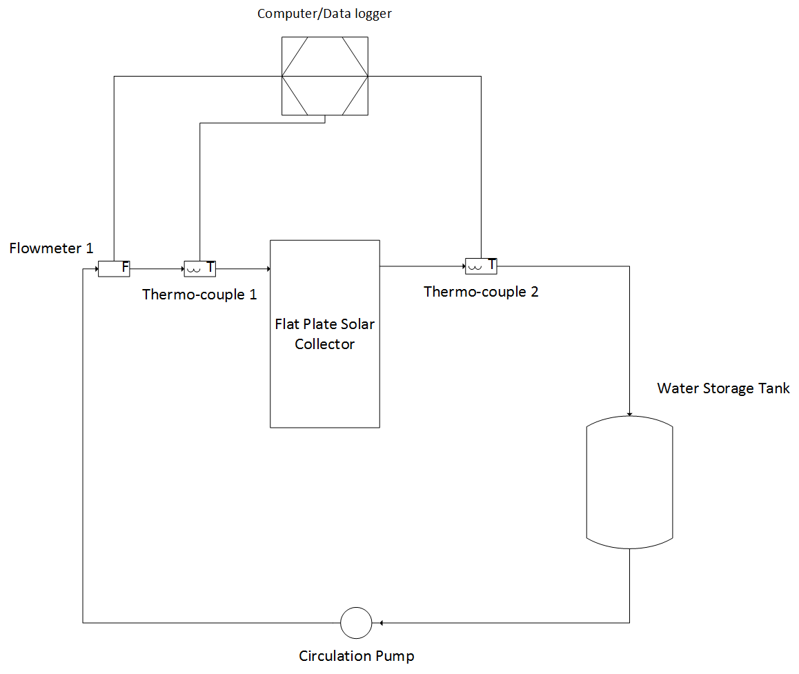

# Modelling

* The model will be constructed out of basic principles.
* Python will be used as a centre link between all the input and output files.
* The outputs will mostly consist of graphs?
* The inputs will have to be specified and categorized as ‘variable’ and ‘constant’
* The model will be tested against the experimental results
* (Optional) A python program solving the optimum design parameters based on a given data set.
* (Optional) The model can be tested against another model as well
* Model layout:

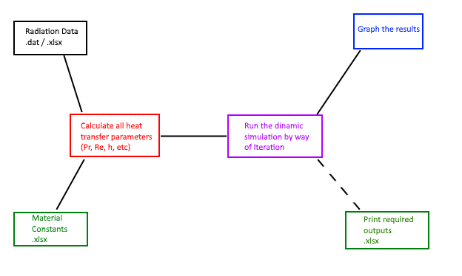

# Literature survey

* I’ll need to look at various models to get a good grasp of things
* A detail drawing and layout of the solar collector is needed, in order to set up equations out of first principles
* Background history is important as well, in order to define the purpose of the investigation very clearly.
* A lot of heat transfer and material data is needed to run the simulation.